**Task-1**

Consider the following dataset to find missing values using KNN imputer method.

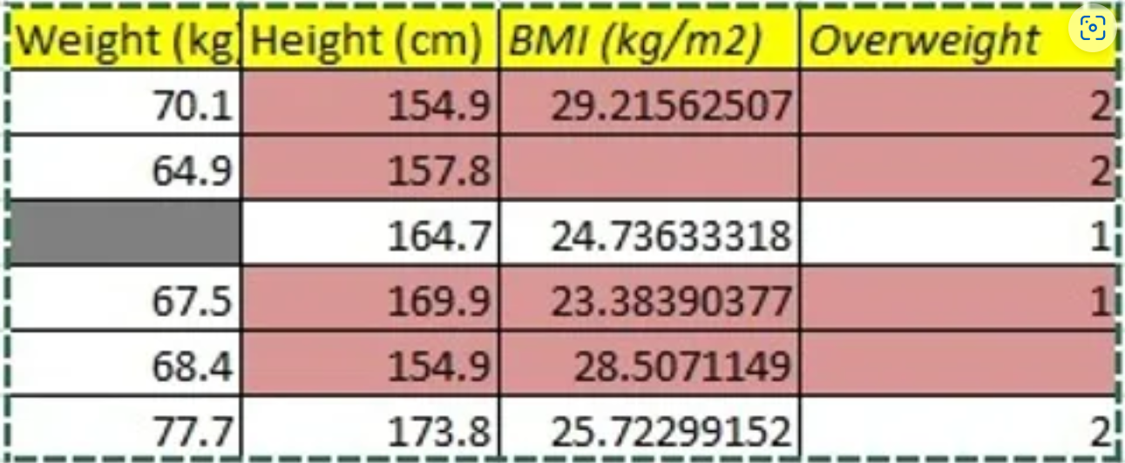

* First, create a pandas data frame and find out columns with missing values.
* Then, write a KNN_imputer function to fill the missing entries in the dataset starting from the first column. (Take nearest_neighbours K = 2)
* Now, use the inbuilt KNN_imputer function with K=2 and find out the missing entries.
* Compare the outcomes.

**Task-2**

Download the following iris dataset and perform the same task as mentioned above. (Take k=3)

<https://docs.google.com/spreadsheets/d/1JelvyRIKVExEoq0XNJUBspOjS_1oYsR5Cak7CqaVfHM/edit?usp=sharing>